Academic Support Services

Testing Services

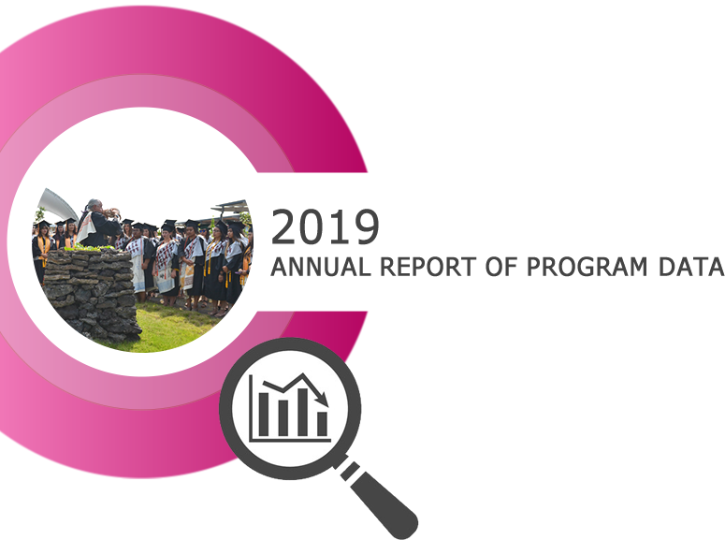
1. Program Description

2. Analysis of the Program

3. Student Learning Outcomes

3a. Expected Level of Achievement

3b. Courses Assessed

3c. Assessment Strategy/Instrument

3d. Results of Program Assessment

3e. Other Comments

3f. Next Steps

4. Action Plan

5. Resource Implications

Appendix: Quantitative Indicators
# | Student and Faculty Information | 2016-17 | 2017-18 | 2018-19
1 | Annual Unduplicated Student Headcount | 3,636 | 3,527
2 | Annual FTE Faculty | 125 | 118
2a | Annual FTE Staff | 147 | 151
3 | Annual FTE Student | 1,585 | 1,540

# | Demand Indicators | 2016-17 | 2017-18 | 2018-19
4 | Number of placement test sessions administered per year per student FTE | 0 | 0
5 | Number of Distance Learning tests administered per year per student FTE | 0 | 0
6 | Local campus tests proctored per year per student FTE | 0 | 0

# | Efficiency Indicators | 2016-17 | 2017-18 | 2018-19
7 | Number of test sessions administered per FTE testing center staff | 0 | 0
8 | Annual operational testing center budget allocation per number of test sessions administered | $0 | $0

# | Effectiveness Indicators – Satisfaction measurements using Common Survey Questions | 2016-17 | 2017-18 | 2018-19
9-1 | The hours at the Testing Center meet my needs | 0% | 0%
9-2 | The atmosphere at the Testing Center is conducive to testing | 0% | 0%
9-3 | The services at the Testing Center are satisfactory | 0% | 0%
9-4 | My test was administered in a timely and efficient manner | 0% | 0%

